MEMORY REPRESENTATION OF BINARY TREE

Two different
possible
representations are possible of a binary tree they are:

Sequential
representation using single dimension array

Linked list
representation using a doubly linked list.
^{GFGC, MALUR} 2
Sequential representation
Rules to determine the locations of the parent, left child and right child of any node I in the binary tree using array.
1. Store the root node in the first location of the array TREE
2. If a node is present in the location I of the array TREE then store its left child in the location 2* I
3. If a node is present in the location I of the array TREE then store its right child in the location 2* I+1.
GFGC, MALUR 3
Array-Based Representation
1 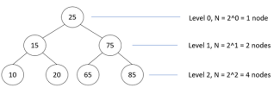
2 3
4 6
5 7
1 2 3 4 6
5 7
GFGC, MALUR 4
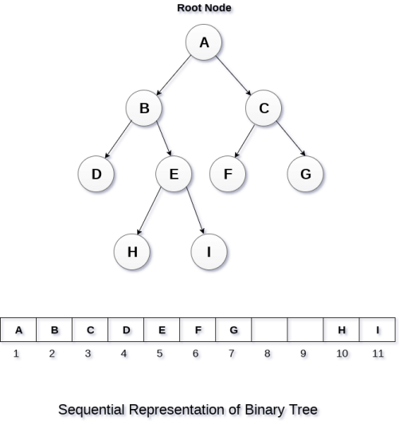GFGC, MALUR 5
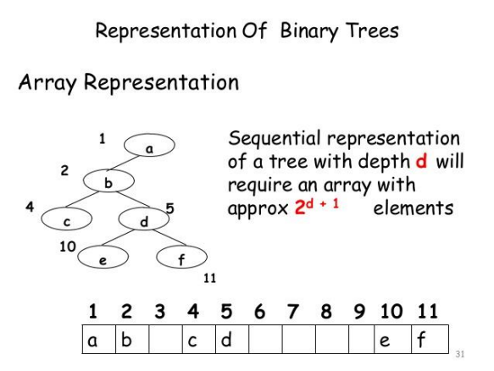GFGC, MALUR 6
Linked Representation
■ In this representation, the binary tree is stored in the memory, in the form of a linked list where the number of nodes are stored at non contiguous memory locations and linked together by inheriting parent child relationship like a tree.
■ Every node contains three parts : pointer to the left node, data element and pointer to the right node.
■ Each binary tree has a root pointer which points to the root node of the binary tree.
■ In an empty binary tree, the root pointer will point to null. GFGC, MALUR 8
Linked Representation Example
root
d
f
a
b c
leftChild
element
rightChild
e
g
h
GFGC, MALUR 9
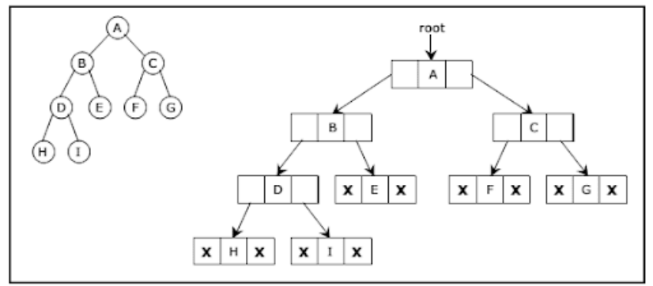GFGC, MALUR 10
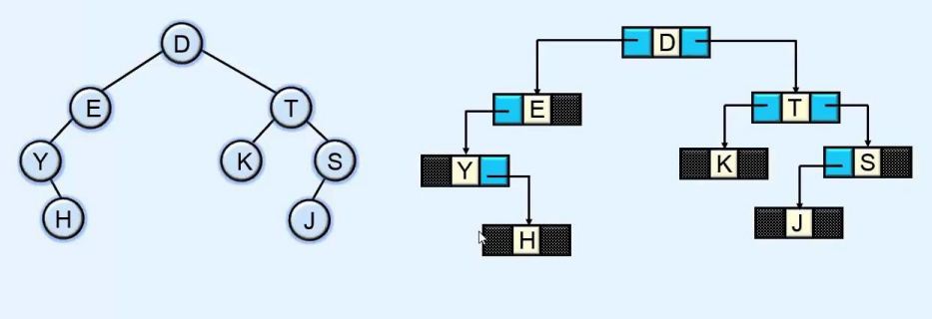GFGC, MALUR 11
Advantage of Linked Representation:
• No data movement required for Insertion and Deletion
• No movement of nodes except the
rearrangement of
pointers
Disadvantage of Linked Representation
• Given a node structure, it is difficult to determine its parent node
• Wastage of memory space in storing NULL pointer for the nodes which have no subtrees.
GFGC, MALUR 12
Practice Exercise –
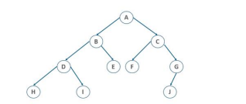
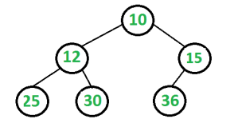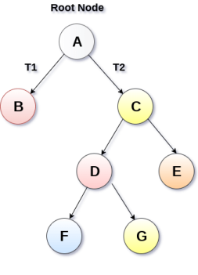GFGC, MALUR 13
TRAVERSING BINARY TREES
GFGC, MALUR 14

SN | Traversal
1 | Pre-order Traversal
2 | In-order Traversal
3 | Post-order Traversal

BINARY
TREE
TRAVERSAL
GFGC, MALUR 15
Pre-order Traversal
1.Visit root node
2.Visit all the nodes in the left subtree 3.Visit all the nodes in the right subtree
Preorder (Root, Left, Right) : 1 2 4 5 3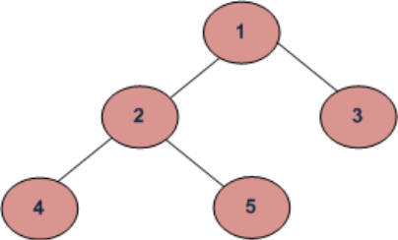
GFGC, MALUR 16
In-order Traversal
ALGORITHM
1.First, visit all the nodes in the left subtree 2.Then the root node
3.Visit all the nodes in the right subtree Inorder (Left, Root, Right) : 4 2 5 1 3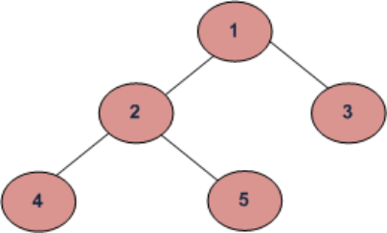
GFGC, MALUR 17
Post-order Traversal
ALGORITHM
1.Visit all the nodes in the left subtree 2.Visit all the nodes in the right subtree 3.Visit the root node
Postorder (Left, Right, Root) : 4 5 2 3 1
GFGC, MALUR 18
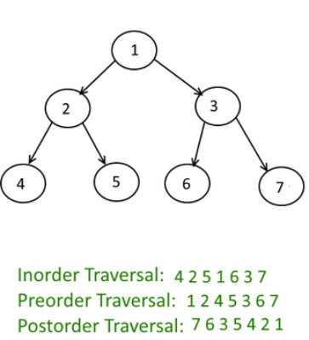
In Binary Tree
Traversing:
Inorder (Left, Root, Right)
Preorder (Root, Left, Right)
Postorder (Left, Right, Root)
GFGC, MALUR 19
Inorder (Left, Root, Right)
Preorder (Root, Left, Right)
Postorder (Left, Right, Root)
GFGC, MALUR 20
PRACTICE EXCERCISE GFGC, MALUR 21
References
1.https://www.javatpoint.com/binary-tree
2.https://www.slideshare.net/aakashdeepsinghal/lecture-8-e 3.https://www.youtube.com/watch?v=NKvOc58_tPM 4.https://www.geeksforgeeks.org/given-linked-list
representation-of-complete-tree-convert-it-to-linked representation/
5.https://www.quora.com/What-are-the-advantages-and disadvantages-of-sequential-representation-of-a-binary-tree 6.http://examradar.com/binary-trees/
7.http://javabypatel.blogspot.com/2017/04/postorder traversal-binary-tree-java.html
GFGC, MALUR 22
THANK YOU
GFGC, MALUR ₂₃

